**Aqsa Tauheed (2303-KHI-DEG-011)**

**Muhammad Huzaifa Waseem (2303-KHI-DEG-021)**

**Unit 1.1: Graded Assignment: RSYNC**

On a linux server setup a cron job for copying example data with *rsync* periodically.  
  
Ensure the copying is handled in the background and independently of the user session.

**What is Cron job?** In Cron job user doesn’t need to do anything by their end. Server automatically runs the code to perform job at particular time period like after every second, minute, every day, every week and every month.

**We use Cron job to automate our task.**  
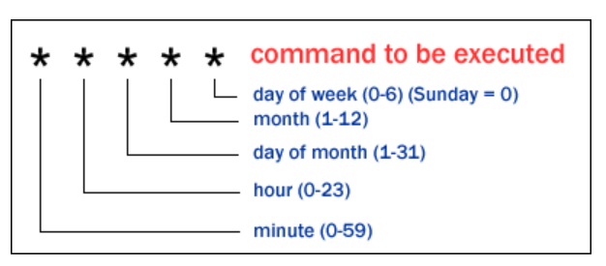  
we copy this image from this site: https://stackoverflow.com/questions/27775550/how-to-write-a-cron-job-for-only-10-days

**What is RSYNC?** Rsync is used to send files from source to destination and is also a free Linux tool and also it is updated the required part which we want to update in our file.

* **Sudo apt install cron**

from this command we install cron job in our system but we don’t need to install because cron job is already installed in our system.

* **crontab -e**

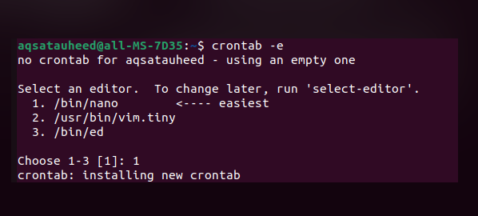from this command we create or activate an cron job environment to perform our task.

* **sudo apt-get install rsync**

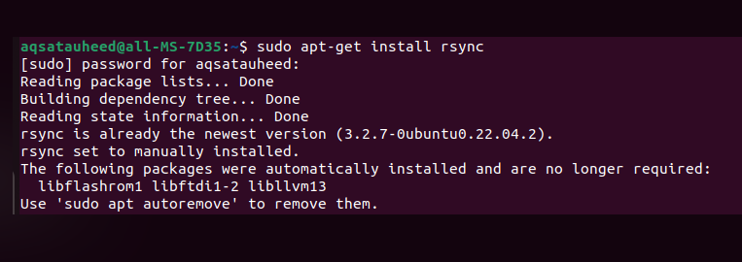from this command we install an rsync in our linux system to perform the following task such as moving large files from source to destination.

* **\* * * * * rsync – av / source path / destination path**

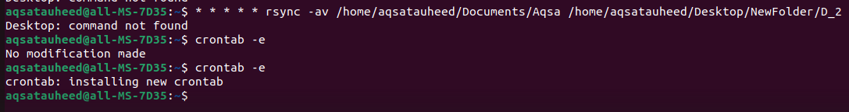from this command we set one minute to perform the task to move files from one source to another.